Assignment 5 by Joshua Troup

1. What was the COST of the items sold in the Little Rock store of Dillard’s?

**$4,720,431.70**

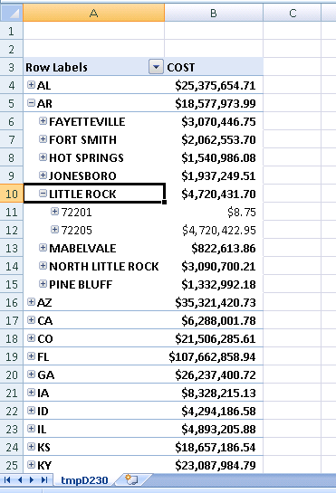

1. List the zip codes of Dillards stores in Little Rock along with the cost of items sold.

**72201-$8.75**

**72205-$4,720,422.95**

Screenshot shown above.

1. What is the AMT (amount) of items sold at Las Vegas stores?

**$35,085,197.70**

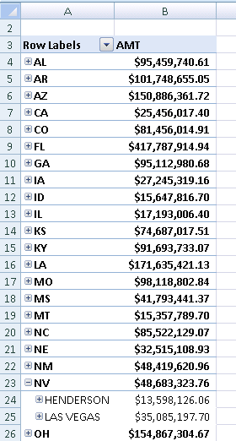

1. What are the AMT (amount) of items sold at Austin for Q3 and Q4 of year 2004? Is the amount of items sold in Q3 of 2005 any better than the previous year Q3 sales? If yes, justify your statement.

**Q3 2004-$3,954,566.08**

**Q4 2004-$7,950,632.99**

**Q3 2005-5,183,108.68**

**Yes the amount of items sold from Q3 2004 to Q3 2005 was increased by $1,228,542.60.**

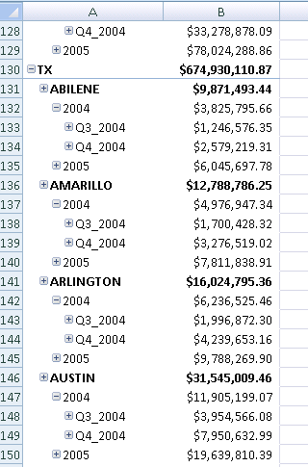

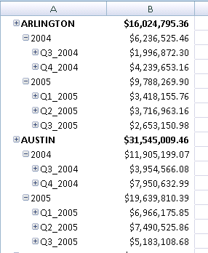

1. What is the state where the AMT (amount) of REEBOK Brand items sold were maximum? What is the numerical value of this maximum sales?

**Florida had the largest amount of Reebok items sold**

**Tampa had the highest sales which were $7,553.67**

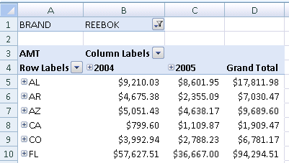

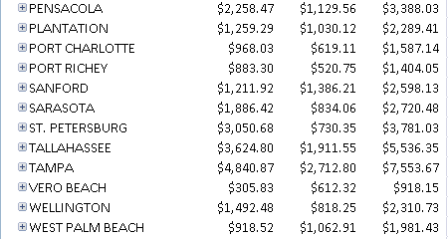

1. What is the Profit Margin for the Dillard’s store at Austin, TX ?

**10.22%**

